

Phase 2: Remote Shell Implementation
  - COSC 354 : Operating Systems
Spring 2026
by

Abi Ali Murtaza Ghadiyali 100066653
Muhammad Awais Afzal Mirza 100066617

Table of Contents:
Introduction: 2
System Architecture: 2
Key Components: 3
1) Shared Definitions (shell_common.h) 3
Server Modules 3
2) Socket setup 3
3) Session Management 3
4) Command Processing 4
5) Built-in commands 4
6) Command execution 4
7) Output handling 5
Client Modules 5
Communication Protocol: 6
Features Implemented: 6
Outputs: 7
Limitations: 7
Conclusion: 7

Introduction:
In this phase, the local shell from Phase 1 was extended into a remote shell using client-server architecture. The system allows a client to send commands to a server over a network using TCP sockets. The server processes the commands and returns the results to the client.
This phase demonstrates:
- socket programming
- remote command execution
- inter-process communication
- reuse of Phase 1 shell logic

System Architecture:
The system consists of two programs:
-) Client
- Takes user input
- Sends commands to server
- Receives results
- Displays output
-) Server
- Accepts client connection
- Parses commands
- Executes commands (using Phase 1 logic)
- Sends results back

Key Components:

Shared Definitions (shell_common.h)
Defines:
constants (PORT, MAX sizes)
status codes:
  - STATUS_OK
  - STATUS_ERROR
  - STATUS_CLEAR
  - STATUS_EXIT
Command Result struct for communication

Server Modules

Socket setup
- setup_server_socket()
- accept_client()
Handles server creation and client connection

Session Management
-) initialize_session()
-) handle_client_session()
Maintains:
- client socket
- session directory
- session state

Command Processing

-) process_command()

Decides:
- empty input
- built-in command
- single command
- pipeline command

Built-in commands
-) handle_builtin()
Supported:
- cd → change directory (session-based)
- clear → clear client screen
- exit → end session

Command execution
Single commands:
- execute_single_command()
- uses fork() + execvp()
- captures output using pipes
Piped commands:
- execute_pipe_commands()
- supports up to 3 pipes
- redirects output between processes

Output handling
-) store_output()
Reads command output from pipes and stores it in CommandResult.

Client Modules
1) Connection
- connect_to_server()
2) Input Handling
- read_user_input()
3) Communication
- send_command()
- receive_result()
4) Output Handling
- prints command results
- clears screen on STATUS_CLEAR
- exits on STATUS_EXIT

Communication Protocol:
- Client sends a fixed-size command buffer
- server processes command
- Server returns CommandResult struct
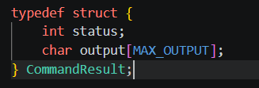

Features Implemented:
- Remote execution of Linux commands
- Built-in commands (cd, clear, exit)
- Pipeline support (1, 2, 3 pipes)
- Output redirection via pipes
- Session-based directory handling
- Client-server communication using TCP sockets

Outputs:
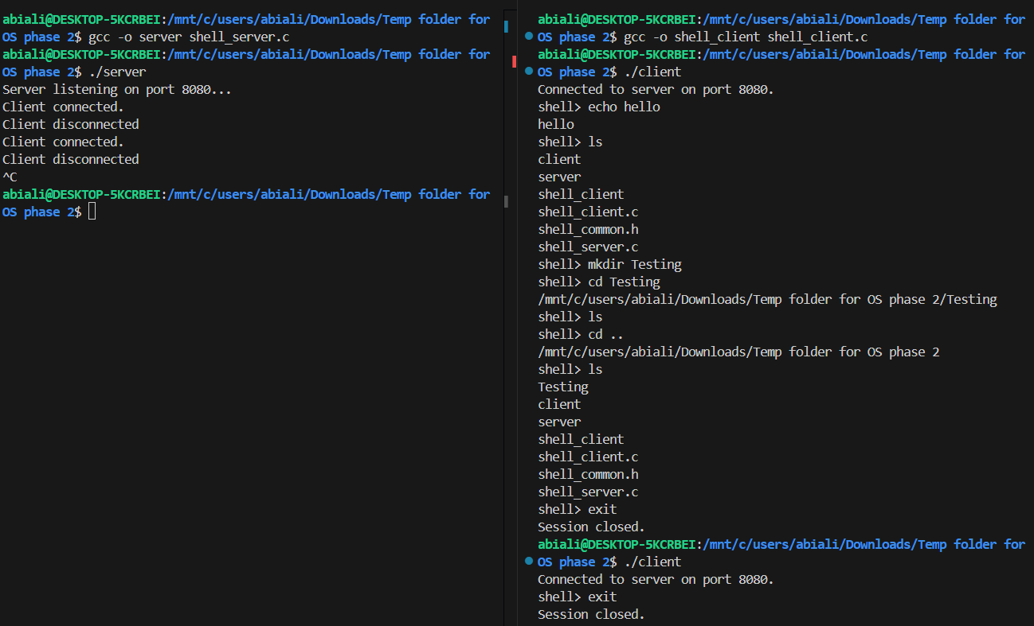

Limitations:
- does not support quoted arguments (e.g., "folder name")
- no support for background execution (&)
- no support for I/O redirection (>, <)
- basic parsing using strtok()
- supports one client at a time

Conclusion:
In this phase, the shell was successfully extended into a remote system using sockets. The implementation demonstrates how command execution can be separated from user interaction and handled over a network. This phase builds a strong foundation for further extensions such as multitasking and concurrent client handling in Phase 3.

